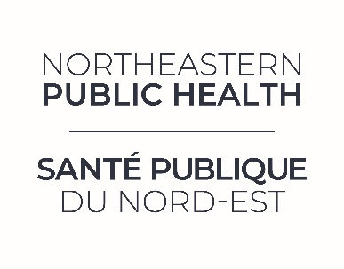
JOB OPPORTUNITY
Public Health Nurse
Competition Number: | 2025.37.TFNL | Program: | Sexual Health/Harm Reduction
Posting Date: | January 12, 2026 | Closing Date: | Open until filled
Location: | New Liskeard | Position Type: | Full-Time, Temporary until February 2027
Salary Range: | $68,460 ($37.62/hr) - $84,129 ($46.22/hr) | Expected Hours: | 35 hrs / Week

POSITION SUMMARY:
Northeastern Public Health (NEPH) is seeking a highly motivated individual knowledgeable in sexual health, immunizations, and harm reduction principles to join its team of public health professionals. This position will involve the provision of sexual health clinical services, needle exchange, Naloxone kit distribution services, and immunizations. The incumbent will also assist other programs, including, but not limited to, community-based clinics and office-based clinics. This position also involves a degree of health promotion and prevention work. For more information about Northeastern Public Health, please visit our website at www.neph.ca.
QUALIFICATIONS:
- Baccalaureate degree in Nursing;
- Current registration with the College of Nurses of Ontario;
- Knowledge of Public Health programming and service delivery;
- Knowledge and awareness of harm reduction principles and theory;
- Excellent interpersonal, communication, and facilitation skills;
- Strong public speaking and facilitation skills;
- Ability to apply appropriate theory and learning principles;
- Transportation to meet programming needs;
- Fluency in both official languages is an asset;
- Satisfactory criminal background check;
- Must comply with immunization policies, including COVID-19 vaccination, unless a valid medical exemption is provided.

HOW TO APPLY:
Only those candidates selected for interviews will be contacted. Please apply to:
Human Resources
Northeastern Public Health
careers@neph.ca

Note: Please ensure the competition number is clearly stated in the subject line.

